Illustrated Excel 2013
Unit E: SAM Project 1a
Northwest Hospital
Analyze worksheet data using formulas

Project Goal
M Project Name
Project Goal

PROJECT DESCRIPTION
Juan Veinot is the HR Director at Northwest Hospital. His assistant has sent him a workbook containing the HR data for the Clinic and Emergency Departments and expansion data for a new hospital wing. He has asked you to help analyze this data using different formulas.

GETTING STARTED
- Download the following file from the SAM website:
  - IL_Excel2013_UE_P1a_FirstLastName_1.xlsx
- Open the file you just downloaded and save it with the name:
  - IL_Excel2013_UE_P1a_FirstLastName_2.xlsx
  - Hint: If you do not see the .xlsx file extension in the Save file dialog box, do not type it. Excel will add the file extension for you automatically.
- With the file IL_Excel2013_UE_P1a_FirstLastName_2.xlsx still open, ensure that your first and last name is displayed in cell B6 of the Documentation sheet. If cell B6 does not display your name, delete the file and download a new copy from the SAM website.

PROJECT STEPS
- On the Emergency worksheet, name the range C6:C14 review_date, and limit the scope of the name to the Emergency worksheet.
- In cell E6, enter a formula to determine the next review date by adding 365 to the review date in cell C6, using the cell name review_date in the formula. Copy the formula in cell E6 into the range E7:E14.
- Delete the range name Last_Name from the workbook. (Hint: Do not delete the cell contents in this range, only the custom range name.)
- In cell G6, create a formula using the IF function to determine the bonus based on the following criteria:
- A bonus is awarded for review scores (in cell D6) higher than 85.
- If the review score is greater than 85, the bonus amount is calculated by multiplying the salary (in cell F6) by .05.
- If the review score is 85 or lower, the bonus amount is 0.
Copy the formula in cell G6 into the range G7:G14.
- Select the range G6:G14. Use the Quick Analysis tool to create a formula that will total the values in that range. The formula should use the SUM function and should appear in the cell G15.
- In cell B20, use the COUNTIF function to count the number of employees with a review score >85. (Hint: Use D6:D14 as the range in your formula.)
- In cell B21, use the AVERAGEIF function to average the salaries of employees with a review score >85 (Hint: Use D6:D14 as the range and F6:F14 as the average_range in your formula.)
- In cell B22, use the SUMIF function to total the salaries of employees with a review score >85. (Hint: Use D6:D14 as the range and F6:F14 as the Sum_range in your formula.)
- Format cells B21 and B22 with the Currency Number format using the $ symbol and two decimal places.
- On the Summary worksheet, in cell B4, create a formula using the SUM function and a 3-D reference to total cell F15 on the Emergency worksheet and cell F15 on the Clinic worksheet.
- Format cell B4 with the Accounting Number format, using the $ symbol and two decimal places.
- In cell E2, enter the text Jay Hollen and use Flash Fill to enter the names into the range E3:E9.
- On the Development worksheet, use the PMT function in cell B9 to determine the monthly payment using the loan information shown in the range B4:B6. (Hint: In your formula, remember to divide the rate value in cell B5 by 12 and use a negative value for the pv value.) Copy the formula from B9 into the range C9:D9.
- In cell B10, enter a formula to calculate the total payments by multiplying the monthly payments by the term months for Loan Option 1. Copy the formula from B10 into the range C10:D10.
- In cell B11, enter a formula that calculates the total interest by subtracting the Loan Amount value by the Total Payments value for Loan Option 1. Copy the formula in B11 to the range C11:D11.
Your workbook should look like the Final Figures on the following pages. Save your changes, close the workbook, and exit Excel. Follow the directions on the SAM website to submit your completed project.

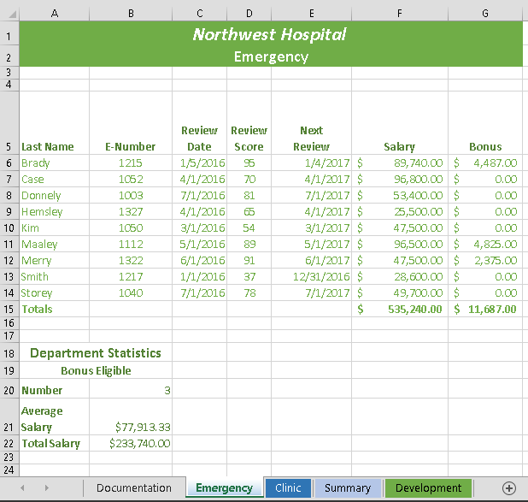
Final Figure 1: Emergency Worksheet
Microsoft product screenshot reprinted with permission from Microsoft Incorporated. Copyright © 2014 Cengage Learning. All Rights Reserved.

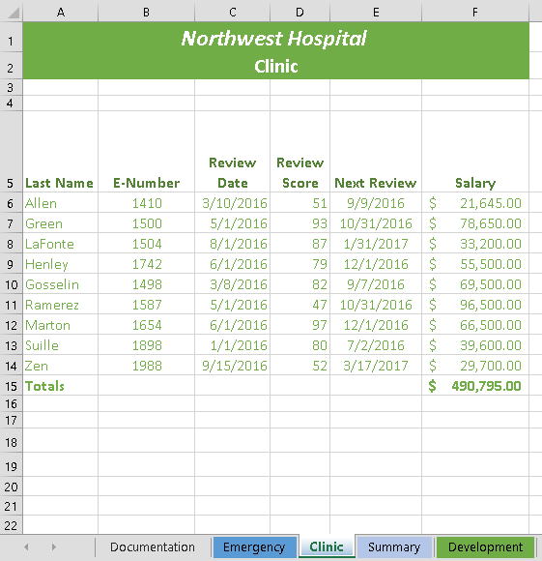
Final Figure 2: Clinic Worksheet
Copyright © 2014 Cengage Learning. All Rights Reserved.

Final Figure 3: Summary Worksheet
Copyright © 2014 Cengage Learning. All Rights Reserved.

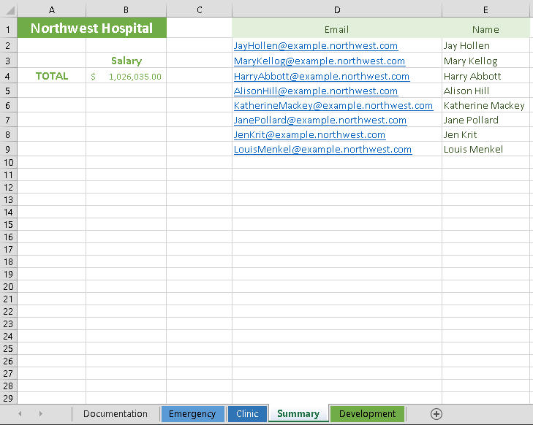

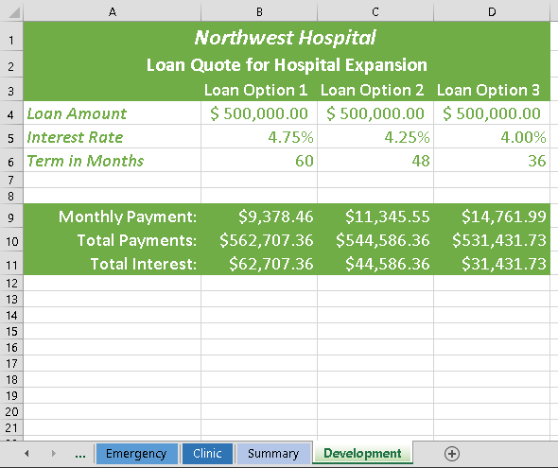
Final Figure 4: Development Worksheet
Copyright © 2014 Cengage Learning. All Rights Reserved.

