New Perspectives Excel 2013
Tutorial 5: SAM Project 1a
Spring Software
WORKING WTH TABLES, PIVOTTABLES, AND PIVOTCHARTS

Project Goal
M Project Name
Project Goal

PROJECT DESCRIPTION
Randall Jackson works in the Human Resources department of Spring Software, a software development company based in Cambridge, Massachusetts. Randall has created a workbook to store and analyze employee data. The workbook is comprised of individual worksheets for each of Spring Software’s regional offices, and a consolidated worksheet for all employees. Randall has asked you to edit some of the worksheet data, sort and filter selected tables to make the data more meaningful, and create PivotTables and PivotCharts.

GETTING STARTED
- Download the following file from the SAM website:
  - NP_Excel2013_T5_P1a_FirstLastName_1.xlsx
- Open the file you just downloaded and save it with the name:
  - NP_Excel2013_T5_P1a_FirstLastName_2.xlsx
  - Hint: If you do not see the .xlsx file extension in the Save file dialog box, do not type it. Excel will add the file extension for you automatically.
- With the file NP_Excel2013_T5_P1a_FirstLastName_2.xlsx still open, ensure that your first and last name is displayed in cell B6 of the Documentation sheet. If cell B6 does not display your name, delete the file and download a new copy from the SAM website.

PROJECT STEPS
- Go to the Cambridge worksheet. Unfreeze the top rows of the worksheet.
- Sort the data in the CambridgePayroll table first in ascending order by the Status field and then in the ascending order by the LastName field.
- Insert a Total Row in the CambridgePayroll table. (Hint: The Total Row should automatically total the values in the 2016 field.) Use the Total Row to calculate the total of the values in both the 2014 and 2015 fields.
- Create a PivotTable based on CambridgePayroll table in a new worksheet titled Cambridge PivotTable. Update the PivotTable as described below so that it matches Figure 1 on the following page.
  - Add the Status field and the LastName field (in that order) to the ROWS area.
  - Add the 2014, 2015, and 2016 fields (in that order) to the VALUES area.
  - Update the Sum of 2014 field in the VALUES area to display the name 2014 Salaries with the Accounting Number format with 0 decimal places.
  - Update the Sum of 2015 field in the VALUES area to display the name 2015 Salaries with the Accounting Number format with 0 decimal places.
  - Update the Sum of 2016 field in the VALUES area to display the name 2016 Salaries with the Accounting Number format with 0 decimal places.

Figure 1: Cambridge PivotTable
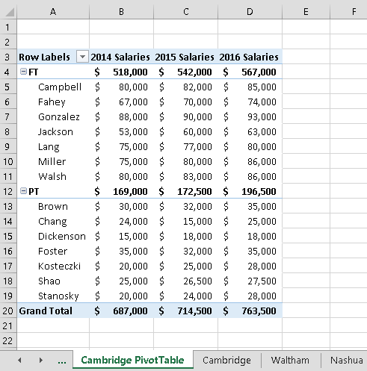
Microsoft product screenshot reprinted with permission from Microsoft Incorporated. Copyright © 2014 Cengage Learning. All Rights Reserved.

- Go to the Waltham worksheet and complete the following steps.
  - Sort the table by the Status field in ascending order.
  - Convert the table to a normal range. (Tip: This option is only available if you do not select the header rows.)
  - Insert subtotals into the range A3:G10, with the subtotals appearing at each change in the Status column value.
  - The subtotals should use the SUM function and include subtotals for the 2014, 2015, and 2016 fields. (Note: Make sure to check the summary below data check box if it is not checked automatically.)
- Go to the Nashua worksheet. Create an Excel table with headers based on the range A3:G8. Rename the table NashuaPayroll and format the table using the Table Style Medium 10 (3rd column, 2nd row in the Medium Table Style section).
- Add the following record as shown in bold in Table 1 below to the end of the NashuaPayroll table:

Table 1: New Record for NashuaPayroll Table

LastName | FirstName | Office | Status | 2014 | 2015 | 2016
Chouhan | _{Danielle} | _{Nashua} | _{PT} | _{$32,000} | _{$33,000} | _{$36,000}

© 2014 Cengage Learning.

- Go to the Framingham worksheet and filter the FraminghamPayroll table to show only those records with a Status field value of PT.
- Delete the duplicate record for Mary Nichols from the FraminghamPayroll table
- Go to the All Employees worksheet and freeze the top row of the All Employees worksheet.
- Use the Find command to find the record for employee Brianne Brown. Edit the record by changing the 2016 field value to $34,000. Close the Find and Replace dialog box.
- Filter the table to show only records for employees who work part-time (Hint: Status field equals “PT”) and who had a 2016 salary greater than or equal to $30,000.
Refer to Figure 2 on the following page while completing Steps 13-17.

Figure 2: Employees PivotTable Worksheet
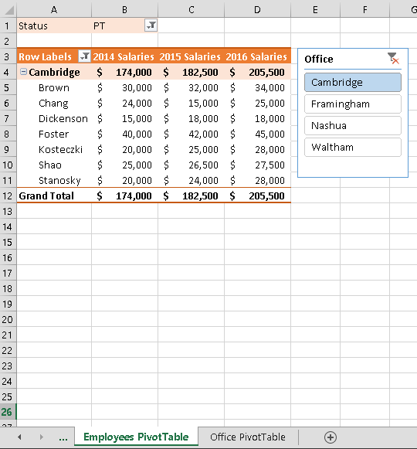
Copyright © 2014 Cengage Learning. All Rights Reserved.
- Switch to the Employees PivotTable worksheet. Refresh the PivotTable data. (Hint: After refreshing the PivotTable, the Brown record in row 5 should now have a 2016 salary field value of $34,000.)
- Apply the Pivot Style Medium 10 PivotTable style to the PivotTable.
- Update the Sum of 2014 field in the VALUES area to display the name 2014 Salaries with the Accounting Number format with 0 decimal places.
- Create a Filter for the PivotTable by adding the Status field to the FILTERS area. Filter the table so that only employees with a PT status are visible.
- Create a Slicer that will filter the PivotTable based on the Office field value. Resize the slicer so that it has a height of 1.75” and a width 1.5”. Move the slicer so that its top-left corner appears in cell E3. Finally, use the slicer to filter the PivotTable so that only employees from the Cambridge office are visible.
- Switch to the Office PivotTable worksheet. Refresh the PivotTable data. Insert a PivotChart with the Clustered Column Chart type. Update the PivotChart as described below to match Figure 3 on the following page.
- Move and Resize the PivotChart so that the top-left corner is in cell E3 and the bottom- right corner is in cell P26.
- Add the chart title Yearly Salaries by Office Location to the PivotChart using the Above Chart option.
- Use the Status axis field button to filter the PivotChart so that only the salary of part-time employees at each office location appears in the graph.

Figure 3: Office PivotTable Worksheet

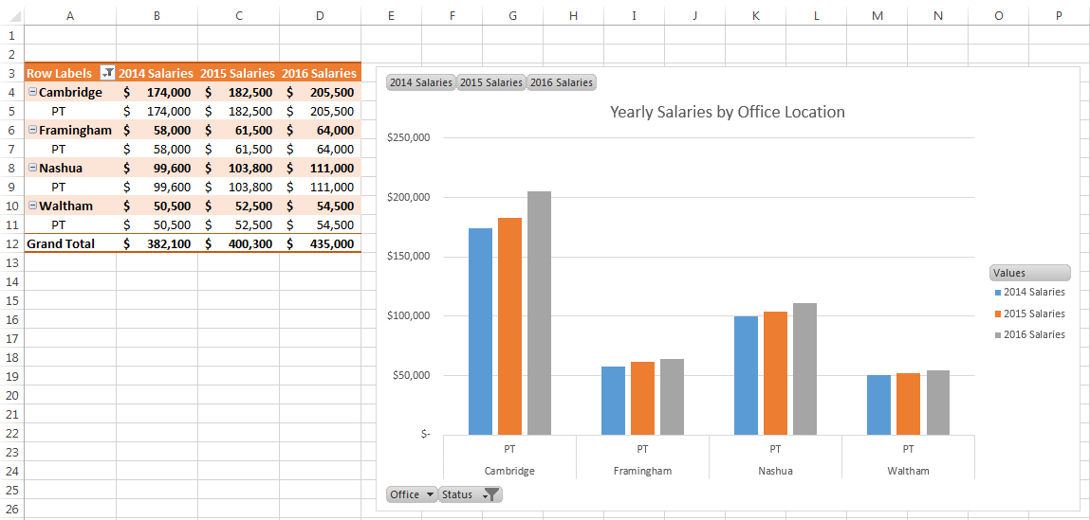
Copyright © 2014 Cengage Learning. All Rights Reserved.

Your workbook should look like the Final Figures on the following pages. Save your changes, close the workbook, and exit Excel. Follow the directions on the SAM website to submit your completed project.

Final Figure 1: Cambridge PivotTable
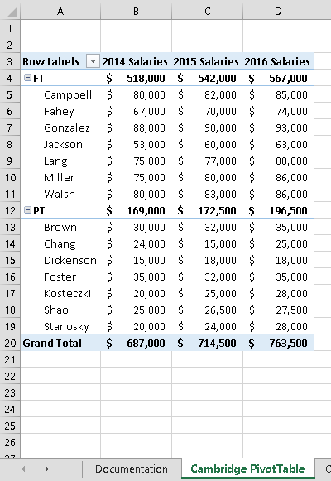
Microsoft product screenshot reprinted with permission from Microsoft Incorporated. Copyright © 2014 Cengage Learning. All Rights Reserved.

Final Figure 2: Cambridge Worksheet

Copyright © 2014 Cengage Learning. All Rights Reserved.
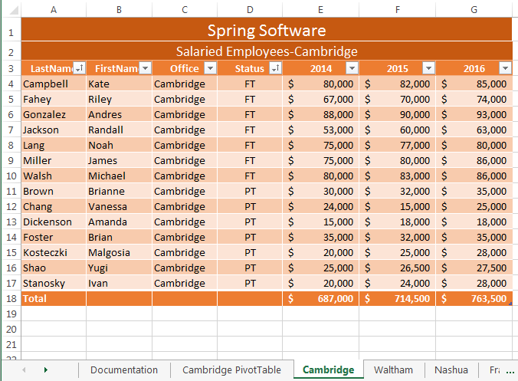

Final Figure 3: Waltham Worksheet

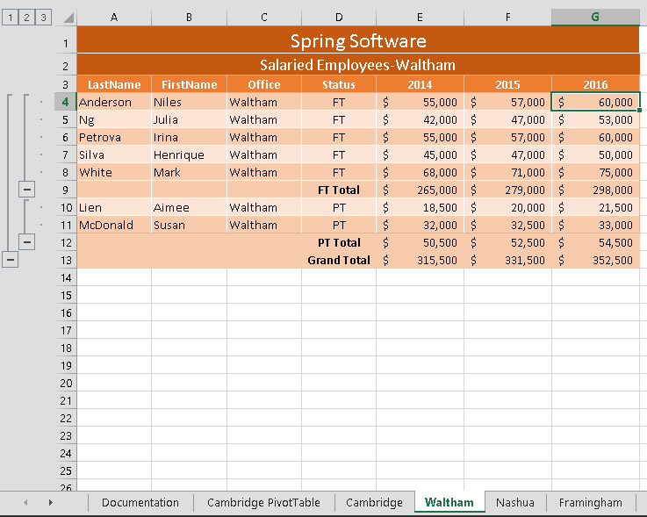
Copyright © 2014 Cengage Learning. All Rights Reserved.

Final Figure 4: Nashua Worksheet
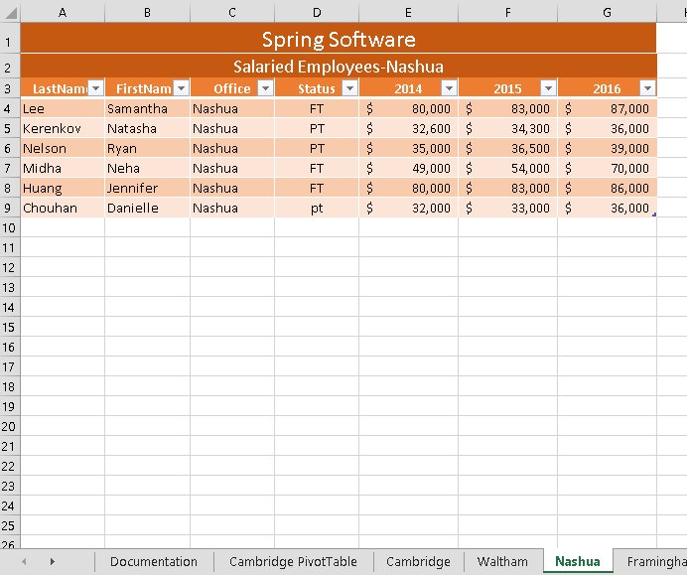
Copyright © 2014 Cengage Learning. All Rights Reserved.

Final Figure 5: Framingham Worksheet
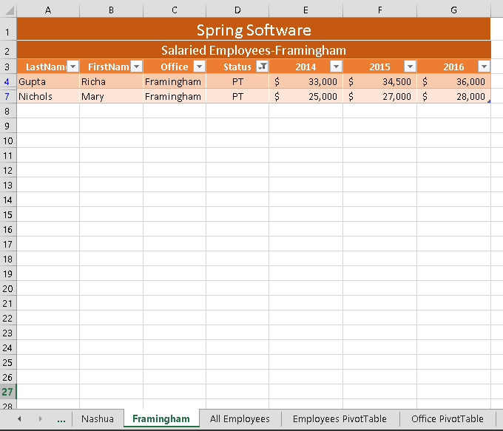
Copyright © 2014 Cengage Learning. All Rights Reserved.

Final Figure 6: All Employees Worksheet
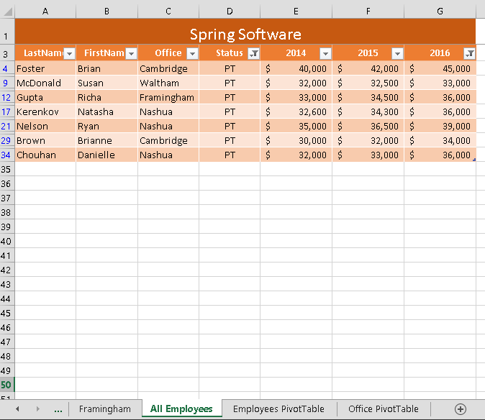
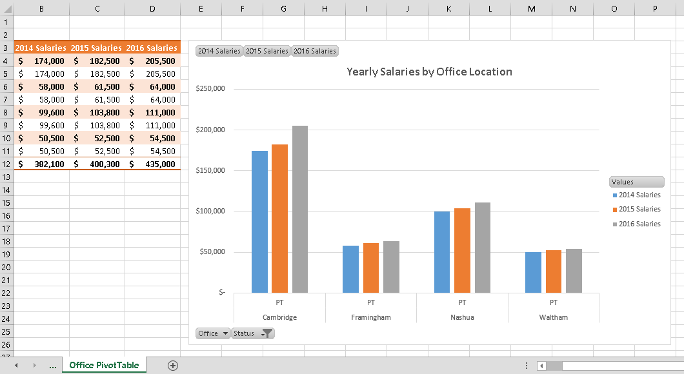
Copyright © 2014 Cengage Learning. All Rights Reserved.

Final Figure 7: Employees PivotTable
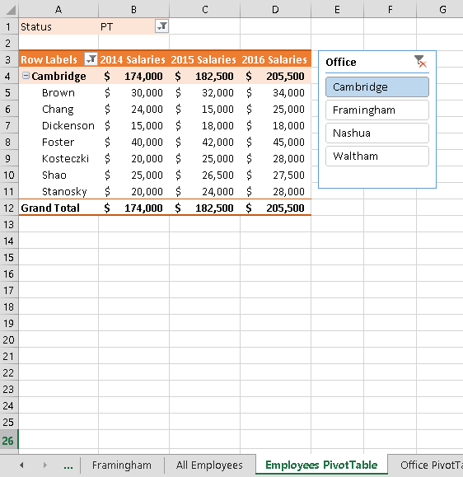
Copyright © 2014 Cengage Learning. All Rights Reserved.

Final Figure 8: Office PivotTable
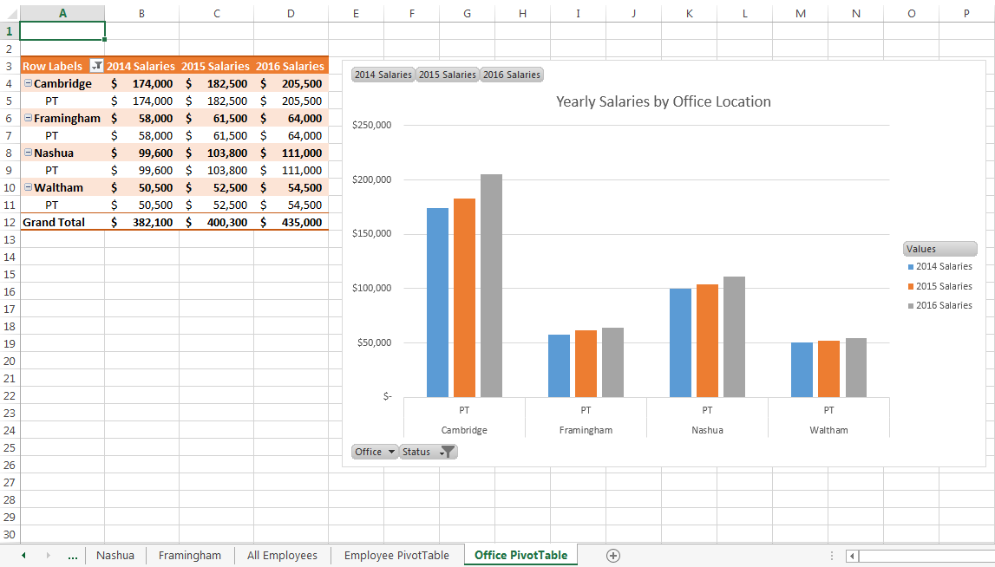
Copyright © 2014 Cengage Learning. All Rights Reserved.

