New Perspectives Excel 2013
Tutorial 3: SAM Project 1b
Gallokol Dance Complex
ENHANCE A TIMESHEET

Project Goal
M Project Name
Project Goal

PROJECT DESCRIPTION
Tim Gallagher is a volunteer with Gallokol Dance Complex, a nonprofit organization that rents and maintains facilities for community dance classes in Springfield, Missouri. He has created a workbook for logging the hours that the complex’s rooms are booked. He would like your help finishing the log.

GETTING STARTED
- Download the following file from the SAM website:
  - NP_Excel2013_T3_P1b_FirstLastName_1.xlsx
- Open the file you just downloaded and save it with the name:
  - NP_Excel2013_T3_P1b_FirstLastName_2.xlsx
  - If you do not see the .xlsx file extension in the Save file dialog box, do not type it. Excel will add the file extension for you automatically.
- With the file NP_Excel2013_T3_P1b_FirstLastName_2.xlsx still open, ensure that your first and last name is displayed in cell B6 of the Documentation sheet. If cell B6 does not display your name, delete the file and download a new copy from the SAM website.

PROJECT STEPS
- On the Room List worksheet, select cells A2:A10 and then use AutoFill to apply the format only to the range B2:B10.
- In cell B3 enter ah, in cell B4 enter bm, in cell B5 type lt, and then use Flash Fill to automatically fill in the values for the range B6:B10.
- On the Room Rental Log worksheet, merge and center the range A1:C1, and then format the range using the Heading 1 Cell Style (1st style in the Titles and Headings section of the Cell Styles palette).
- Merge and center the range A2:C2, and then change the font to Verdana and the font size to 12 pt.
- Center and then format the range A10:C10 using the Heading 2 Cell Style (2nd style from the left in the Titles and Headings section of the Cell Styles panel).
- In cell B5, create a formula using the VLOOKUP function to look up the value of cell B4 (in the current worksheet) in the range A3:B10 on the Room List worksheet and then return the value in the second column of that range. Use FALSE as value of the Range_Lookup argument to specify an exact match lookup.
- In cell B7 of the Room Rental Log worksheet, use the TODAY function to display the current date.
- Use AutoFill to fill the range A12:A25 based on cell A11.
- In cell C11, create a formula that uses the IF function to check if the value in cell B11 is equal to 0.
    - If this condition is true, the current cell should be made empty (equal to "").
    - If this condition is false, the current cell should display the result of multiplying cell B11 (hours booked) by cell B8 (hourly fee). Use a relative reference to cell B11 and an absolute reference to cell B8 so that the formula can be copied to other cells.
- Copy the formula from cell C11 to all cells in the range C12:C25.
- In cell B26, create a formula that uses the SUM function to total cells B11:B25.
- In cell C26, enter a formula that uses the SUM function to total cells C11:C25.
- Format B11:B26 with the Number style, showing two decimal places.
- Format cell B8 with the Currency Number style, showing two decimal places, and then apply the same formatting to the range C11:C26.
- Format the range A26:C26 as bold and then add an Outside border around this range.
- In cell B28, create a formula that uses the MAX function to display the largest value from the range B11:B25.
- In cell B29, create a formula that uses the MIN function to display the smallest value from the range B11:B25.
- In cell B30, create a formula that uses the AVERAGE function to display the average of the values in the range B11:B25.
- In cell B31, create a formula that multiplies the value in cell B30 by 7 (or the number of days in a week).
Your workbook should look like the Final Figure on the following pages. Save your changes, close the workbook, and exit Excel. Follow the directions on the SAM website to submit your completed project.

Final Figure 1: Room Rental Log Worksheet
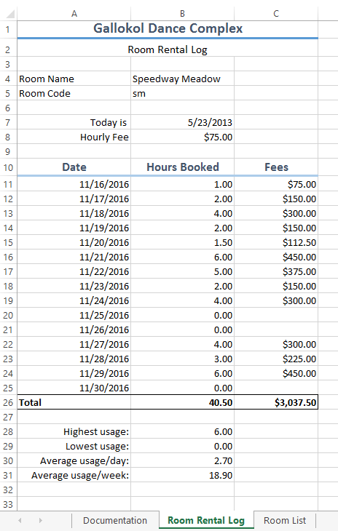
Microsoft product screenshot reprinted with permission from Microsoft Incorporated. Copyright © 2014 Cengage Learning. All Rights Reserved.

Final Figure 2: Room List Worksheet
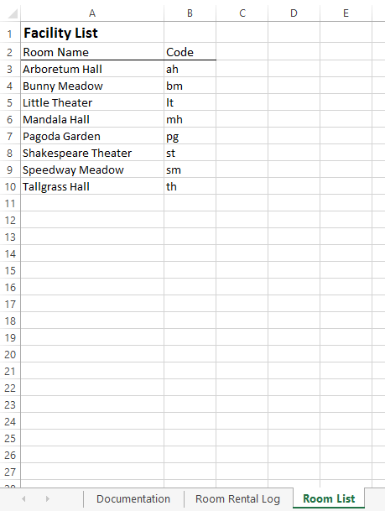
Copyright © 2014 Cengage Learning. All Rights Reserved.

