New Perspectives Excel 2013
Tutorial 1: SAM Project 1b
Green Sprout Farm
CREATE A REPORT OF VOLUNTEER HOURS

Project Goal
M Project Name
Project Goal

PROJECT DESCRIPTION
Annkathryn Murray is the volunteer coordinator at the Green Sprout Farm. The Green Sprout Farm recently started a community supported agriculture (CSA) program, which allows community members to receive a share of the farm’s harvest either by volunteering at the farm or by purchasing a yearly farm share. Annkathryn has started a workbook to track the hours worked by the farm’s volunteers. Her workbook contains two worksheets: Hours Log, which lists and categorizes all volunteer hours, and Hours by Volunteer, which summarizes the hours worked. Annkathryn would like your help adding information to the workbook.

GETTING STARTED
- Download the following file from the SAM website:
  - NP_Excel2013_T1_P1b_FirstLastName_1.xlsx
- Open the file you just downloaded and save it with the name:
  - NP_Excel2013_T1_P1b_FirstLastName_2.xlsx
  - If you do not see the .xlsx file extension in the Save file dialog box, do not type it. Excel will add the file extension for you automatically.
- With the file NP_Excel2013_T1_P1b_FirstLastName_2.xlsx still open, ensure that your first and last name is displayed in cell B6 of the Documentation sheet. If cell B6 does not display your name, delete the file and download a new copy from the SAM website.

PROJECT STEPS
- On the Hours Log worksheet, cut the contents of the range C1:C3 and paste them into the range A1:A3.
- Add Outside borders to the range A5:D5.
- Change the width of column A to 19.5.
- In cell B6, edit the text to read 5.00.
- Enter the data in bold shown in Table 1 on the following page into the corresponding cells in the range B20:B26.

Table 1: Values for Range B20:B26

© 2014 Cengage Learning.
Cell | Value
B20 | _{5.50}
B21 | 2.50
B22 | 3.50
B23 | 2.25
B24 | 1.75
B25 | 2.00
B26 | 4.00

- Select cell A27 and then enter the word Total. Add cell borders to the range A27:B27 using the All Borders border format.
- In cell B27, use the SUM function to create totals for the data in the range B6:B26.
- In cell D6, type RGA, in cell D7, type RHA and then use Flash Fill to automatically enter codes in the range D8:D26.
- Zoom out to 90% on the Hours Log worksheet.
- On the Hours by Volunteer worksheet, change the orientation to Landscape. (Note: Do not change the orientation of the Hours Log worksheet.)
- In cell A2, edit the text to read Hours by Volunteer.
- In the Hours by Volunteer worksheet, change the height of row 5 to 15.00.
- In cell A5, edit the text to read Volunteer.
- Change the width of column D to 24.00.
- Enter the data in bold shown in Table 2 on the following page into the corresponding cells in the range A6:A11.

Table 2: Values for Range A6:A11

© 2014 Cengage Learning.
Cell | Value
A6 | _{Bilal}
A7 | _{Christina}
A8 | _{Kenny}
A9 | _{Omar}
A10 | _{Rita}
A11 | _{Teresa}

- In the cell D6, enter a formula to determine the non-gardening hours, where the non-gardening hours equal the total hours (cell B6) minus the gardening hours (cell C6).
- Copy the formula you created in cell D6 to the range D7:D11.
- In cell A13, delete the text Covers hours logged through September 30, 2016.
- Apply the Wrap text formatting to cell A14.
- Zoom in to 110% on the Hours by Volunteer worksheet. (Note: Leave the zoom at 90% for the Hours Log worksheet.)
- Move the Hours Log worksheet to the left of the Hours by Volunteer worksheet. (Hint: The Hours Log worksheet should be between the Documentation and the Hours by Volunteer worksheets.)
- Insert a new worksheet in the workbook, rename the worksheet Hours by Date, and move the new worksheet to the end of the workbook.
Your workbook should look like the Final Figure on the following pages. Save your changes, close the workbook, and exit Excel. Follow the directions on the SAM website to submit your completed project.

Final Figure
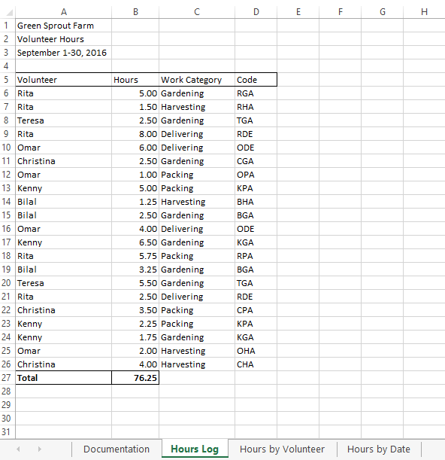
Microsoft product screenshot reprinted with permission from Microsoft Incorporated. Copyright © 2014 Cengage Learning. All Rights Reserved.

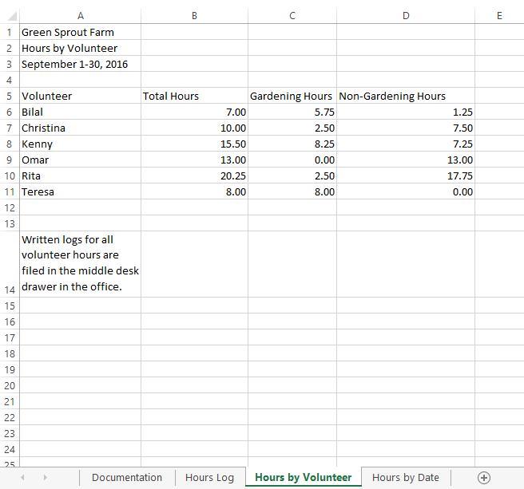
Copyright © 2014 Cengage Learning. All Rights Reserved.

